Kenny Lukito (2602195306)

1. a. The difference is, a class is a set that assigns methods and variables in an object by defining them (in simple terms, it is a description of what the instantiation is), while an instantiation of a class is an individual object created that abides by the methods and variables of its own class (basically, it is an object created abiding the characteristics of the class).

From the example, the classes would be the sale of the products, and its instantiations would be the salaries of the managers, office staff, and sales personnel.

b. The first example is the employee class since employees can be divided into its groups based on their abilities or responsibilities. Another one is the item class since items sold can be divided into categories.

c. Libraries ease up and simplify the code, so it makes the coding process easier and has better quality.

1. a. Here is the completed constructor:

public SalesPerson(String id){  
  
 this.id = id;  
  
}

b. It is necessary since accessor methods are the only way for the SalesPerson class to access private variables of the Sales class.

c. i. Here is the UML diagram for the relationship between the SalesPerson and Sales

classes:

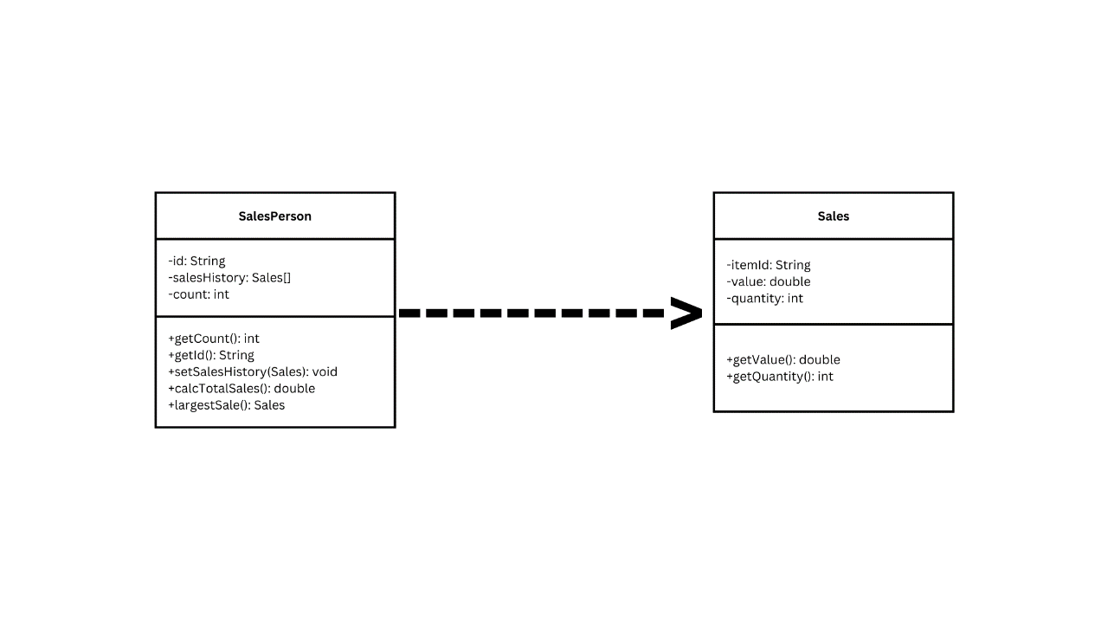

ii. The negative effect is that the (old) existing objects would not be compatible with the new Sales object and it would cause bugs in the code.

d. The output is an error message, which is shown in the following screenshot:

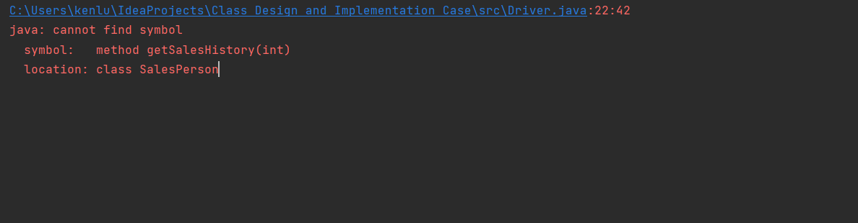

Therefore the code has to be fixed by adding getSalesHistory method in the SalesPerson class. Here is the getSalesHistory class created:

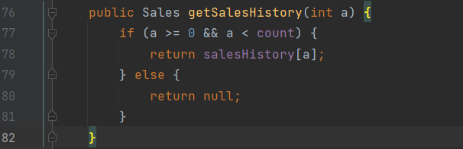

e. The calcTotalSales() method is as follows:

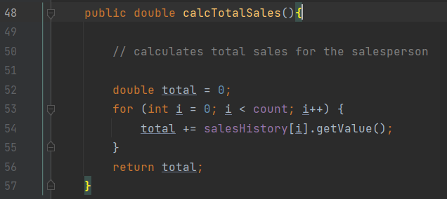

f. Here is the highest() method:

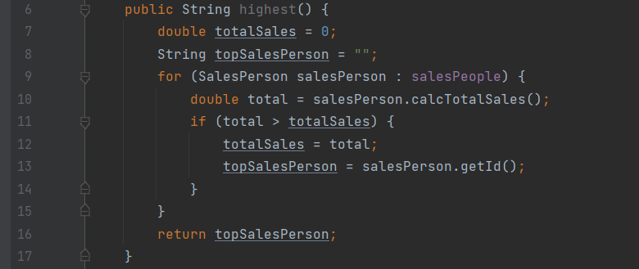

g. Here is the addSales() method:



h. It is advised to make a change by adding a “month” variable to know the end of the month. There should also be a method to calculate the salaries of the salespeople by the end of the month.

i. One remarkable example is that there are 2 constructors by the same name (which is the SalesPerson() constructors). One accepts a string as the parameter (SalesPerson(String id)), and the other accepts 3 different kinds of data types (SalesPerson(String id, Sales[] s, int c_)).